Q17. Prepare report that shows the steps of creating post and page into WordPress and Joomla CMS.
Part A: WordPress
Creating a Post:
- Login to http://localhost/wordpress/wp-login.php .
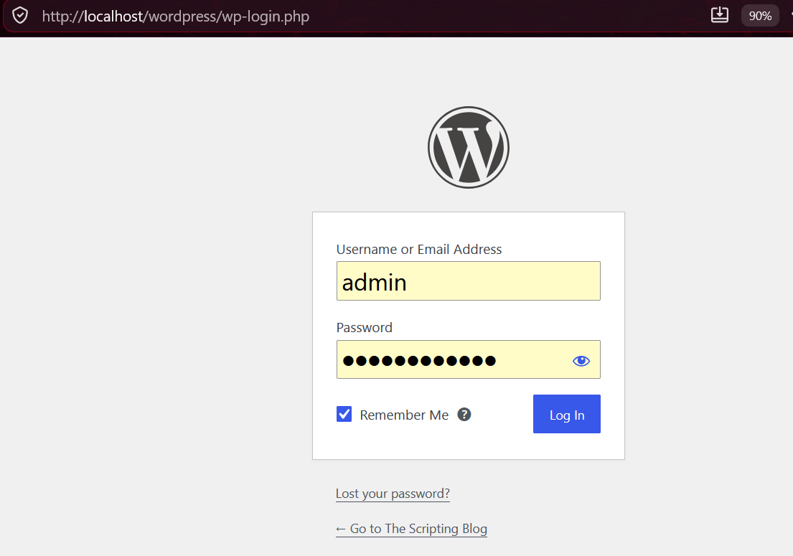

- Go to Posts > Add Post.
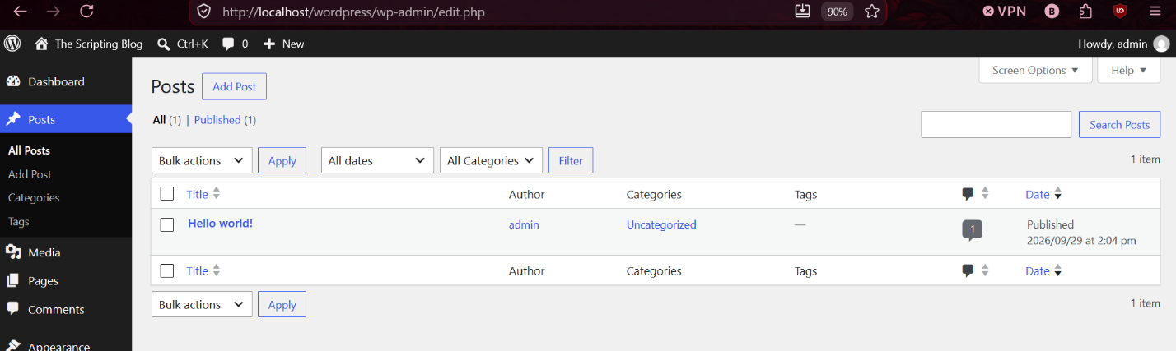
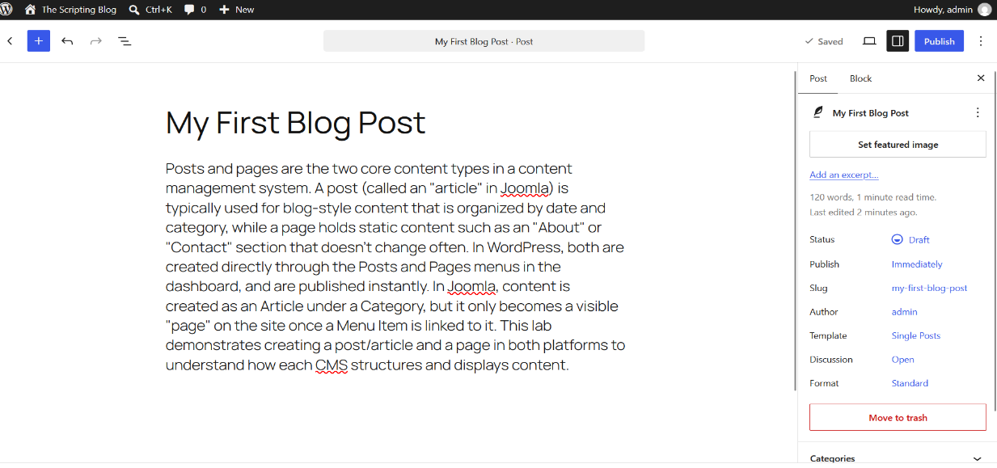
- Enter a title and write content in the editor.

- Add a Category and Featured Image.
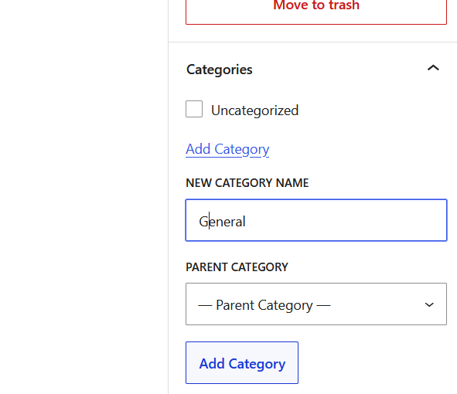

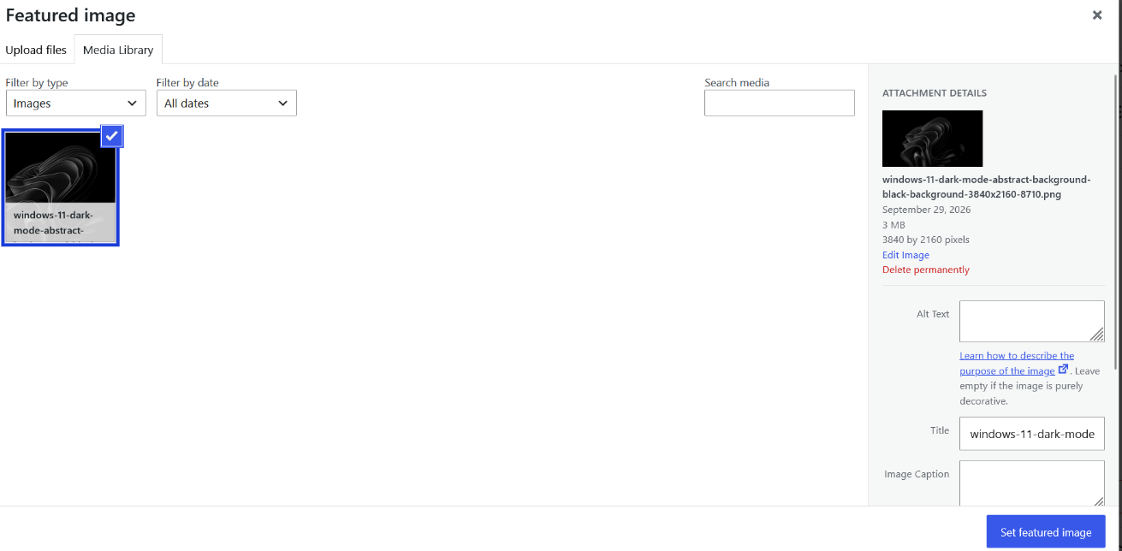

- Click Publish.
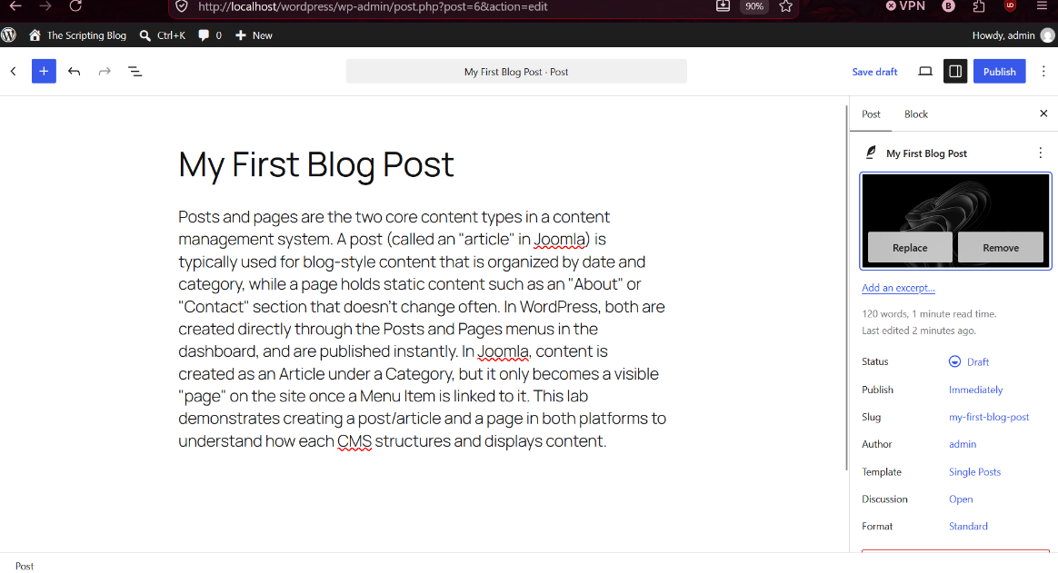

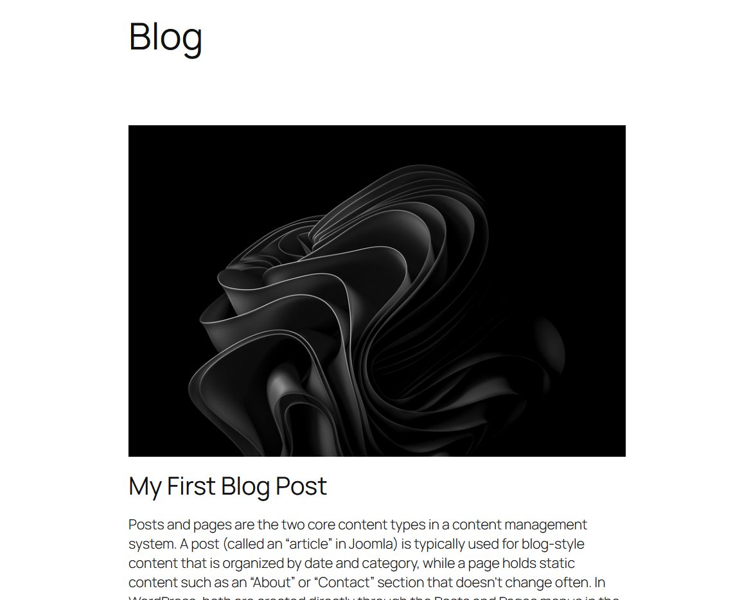

Creating a Page:
- Go to Pages > Add Page.
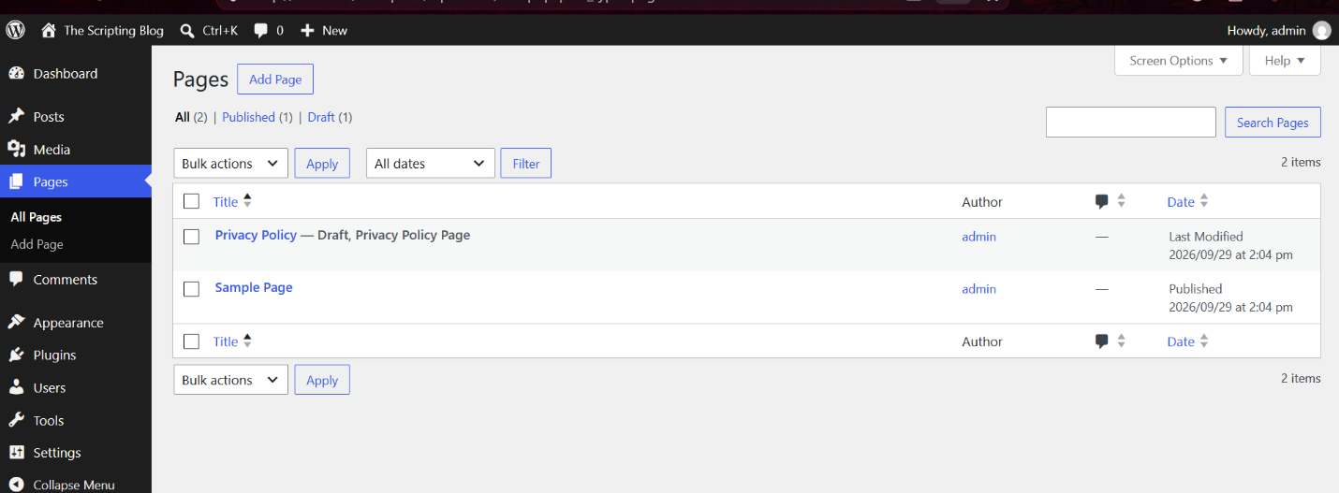
- Enter a title and write content.
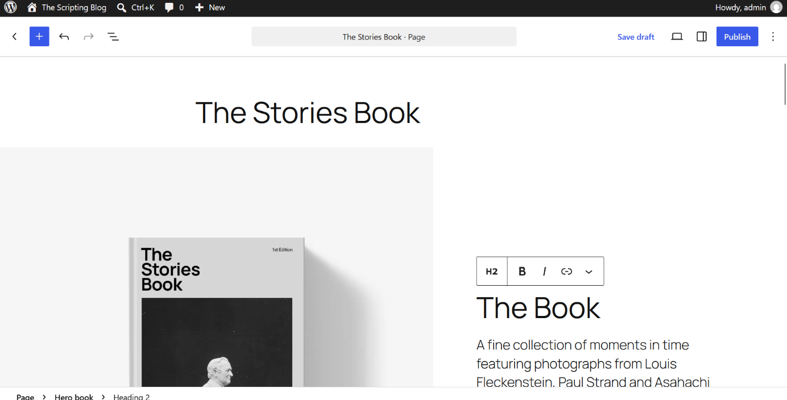
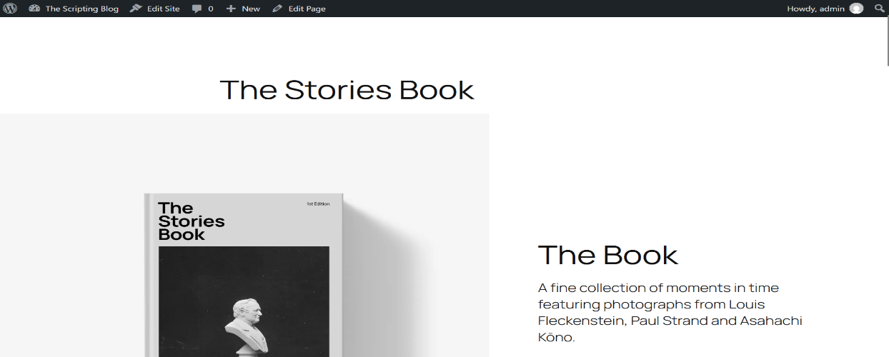
- Click Publish.

Part B: Joomla
Creating a Post (Article):
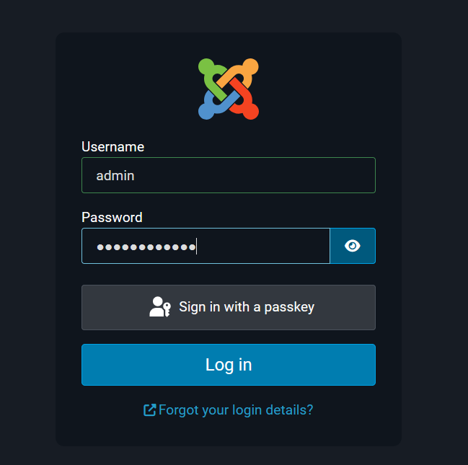
- Login to http://localhost/joomla/administrator.

- Go to Content > Articles > New Article.
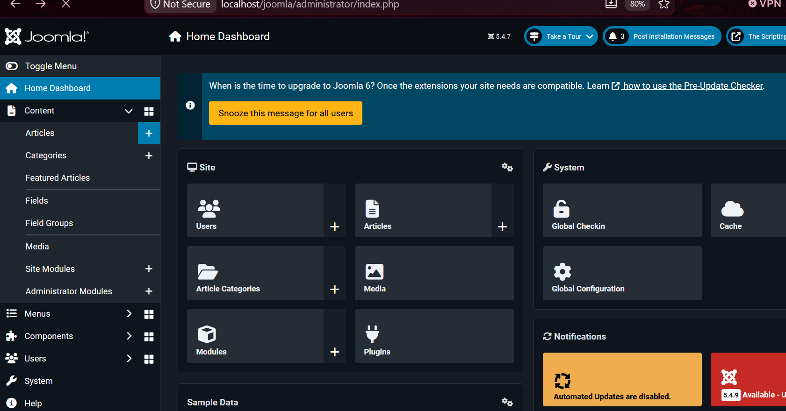

- Enter a title and write content in the editor and Select Category.
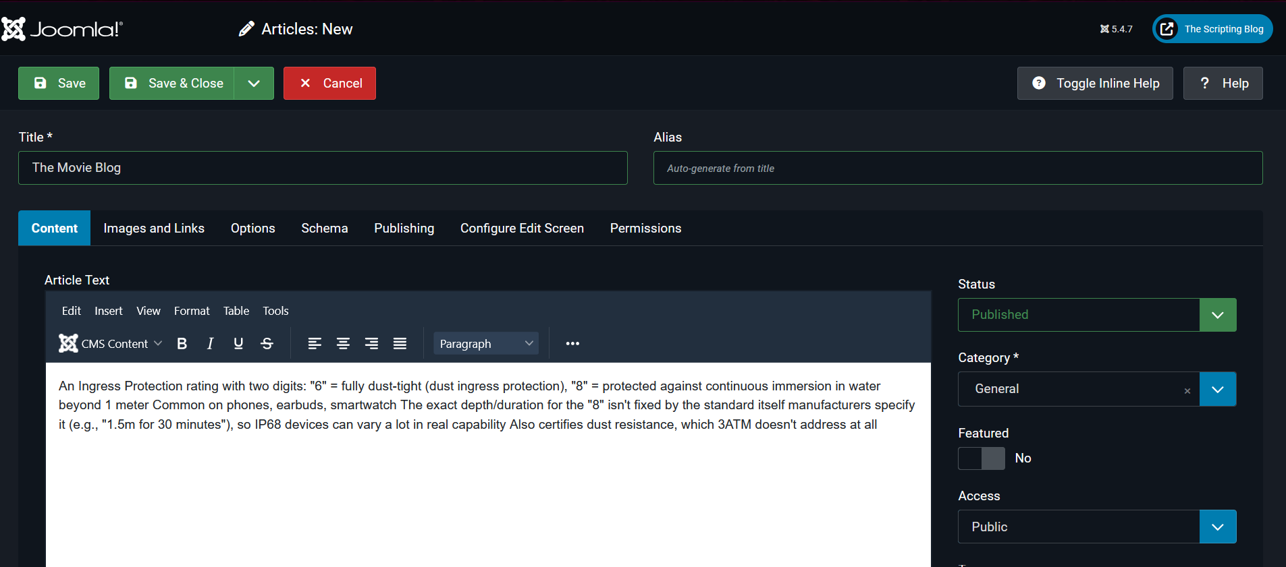

- Click Save & Close.
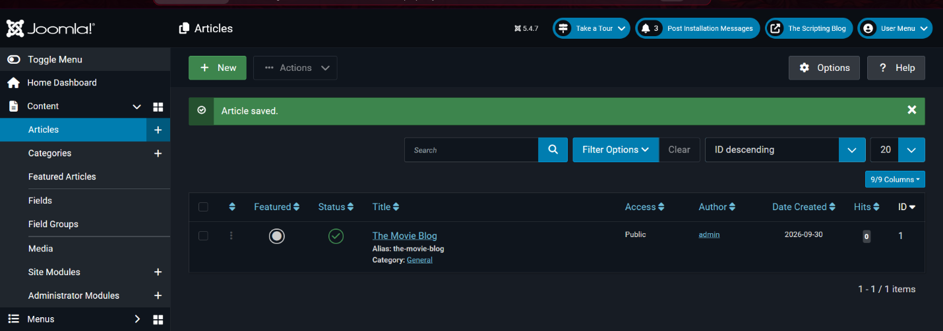

Creating a Page (Menu Item linked to Article):
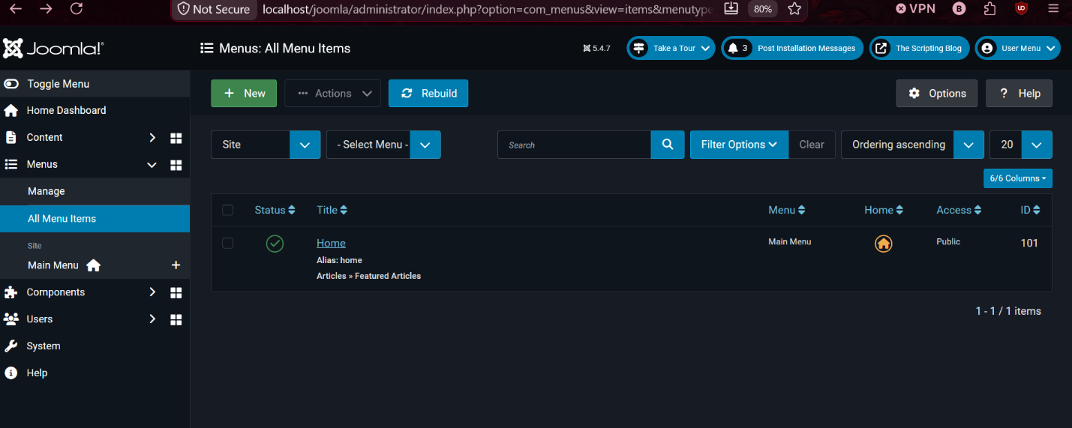
- Go to Menus > All Menu Items > Add New Menu Item.

- Enter a menu title.
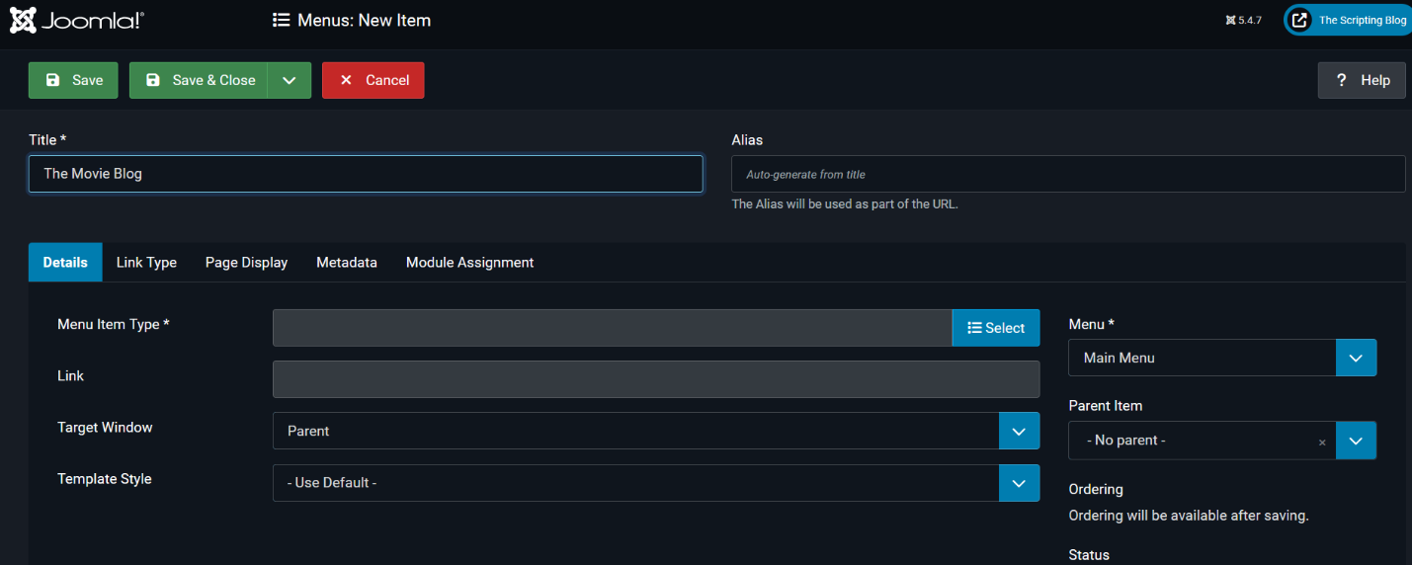

- Select Menu Item Type as Single Article and choose the article.
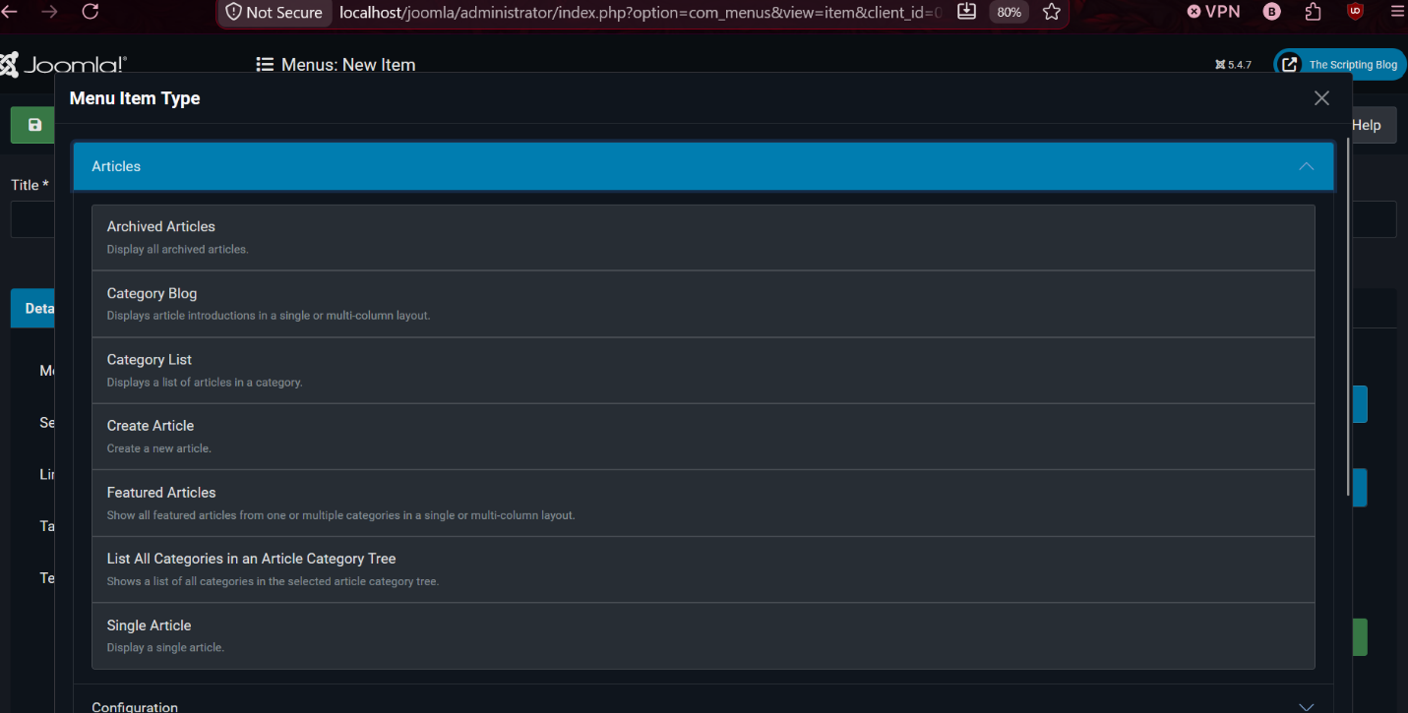
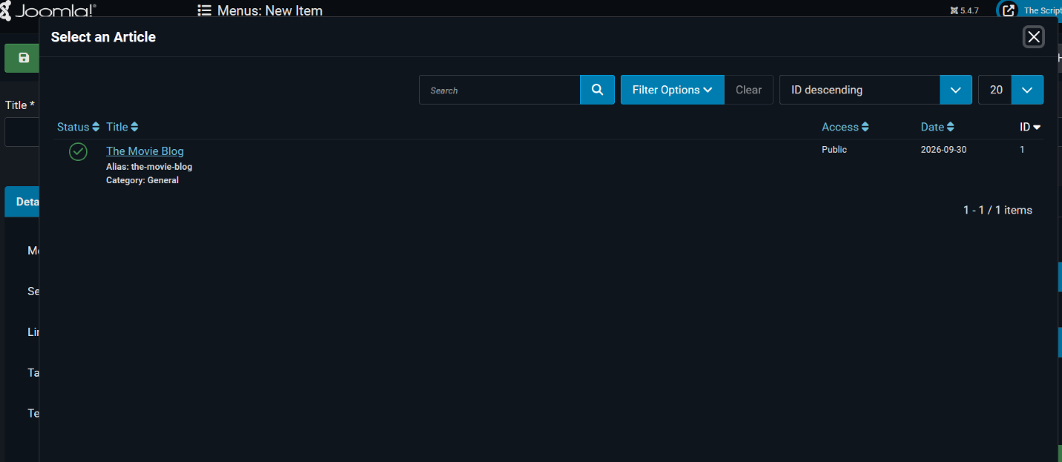

- Click Save & Close. 